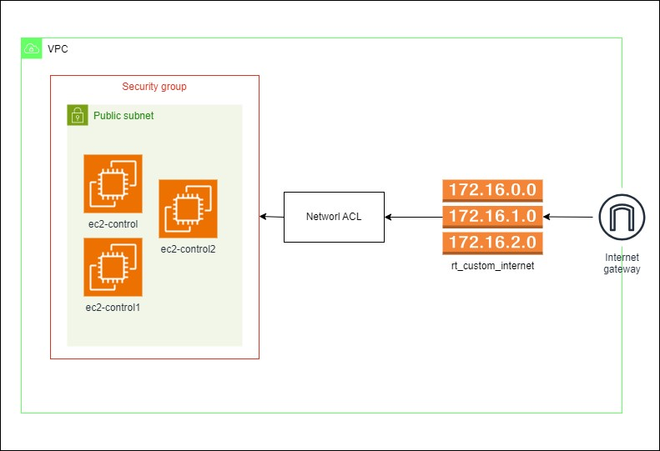

* **Web Application Hosting**: This infrastructure is designed to host a web application that requires internet connectivity. The EC2 instances serve as web servers or application servers, while the Internet Gateway allows users to access the application from the internet.
* **High Availability and Scalability**: The architecture is designed for high availability and scalability, with multiple EC2 instances deployed across availability zones within the VPC. This setup ensures that the application remains accessible even if one availability zone experiences issues.
* **Security and Compliance**: The use of security groups, network ACLs, and other AWS security features are focus on security and compliance requirements. This architecture is designed to meet specific security standards or compliance regulations.
* **Custom Networking Requirements**: The use of custom route tables and network ACLs shows that the infrastructure has custom networking requirements, such as routing traffic through specific paths or applying granular access control policies.